PRESS RELEASE
CONTACT: Mary Beth Duehr marybeth@duehrandassociates.com
Holly Berecz holly@duehrandassociates.com
Duehr & Associates, LLC
1902 Wright Pl, Ste 200
Carlsbad, CA 92008
(760) 918-5622

SieMatic Expands Beyond the Luxury Kitchen, Bringing its Design Expertise to Furniture and the Home

New wall-mounted sideboards with integrated lighting and display cabinets featuring patterned glass introduce a more refined, furniture-inspired approach to kitchen cabinetry, softening the boundaries between the kitchen and living spaces

(Yardley, PA, October 20, 2026) Once again, SieMatic is redefining the modern home. Extending its design expertise beyond the kitchen, the company is creating furniture-inspired elements that respond to the increasingly fluid nature of open-plan living. Sideboards, display cabinets, credenzas, and freestanding buffets bring the precision, customization, and sophisticated aesthetic of SieMatic into adjacent spaces, creating a cohesive design language throughout the home.

“At SieMatic, we believe cabinetry should do more than define a space—it should help shape its character,” says Hans Henkes, President and CEO of SieMatic North America. “By approaching cabinetry more like furniture, we give designers the freedom to create rhythm, balance, and visual interest, bringing greater cohesion to the look and feel of a space.”

The result is a collection of furniture-inspired elements—from wall-mounted sideboards and illuminated display cabinets to fluted credenzas and freestanding buffets—that challenge traditional notions of kitchen cabinetry.

Wall-mounted Sideboard with Integrated Lighting

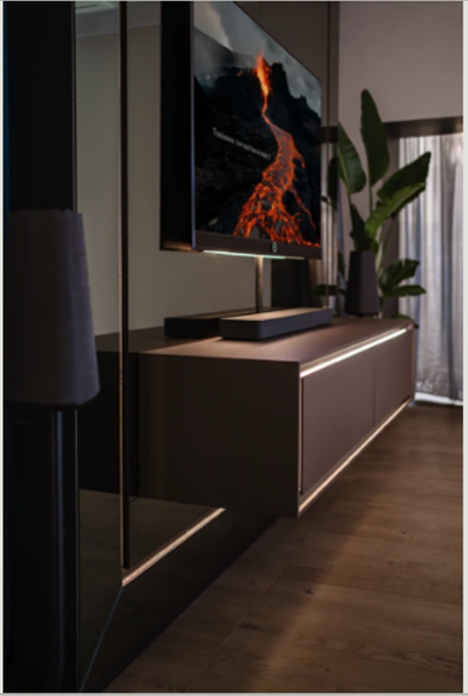

The SieMatic SLX Sideboard makes a strong architectural statement with its wall-mounted, floating configuration and clean, horizontal profile. A continuous recess handle is seamlessly integrated into the design, maintaining an uninterrupted silhouette, while built-in lighting adds a subtle layer of illumination.

Tall Display Cabinets with Illuminated Stone and Patterned Glass

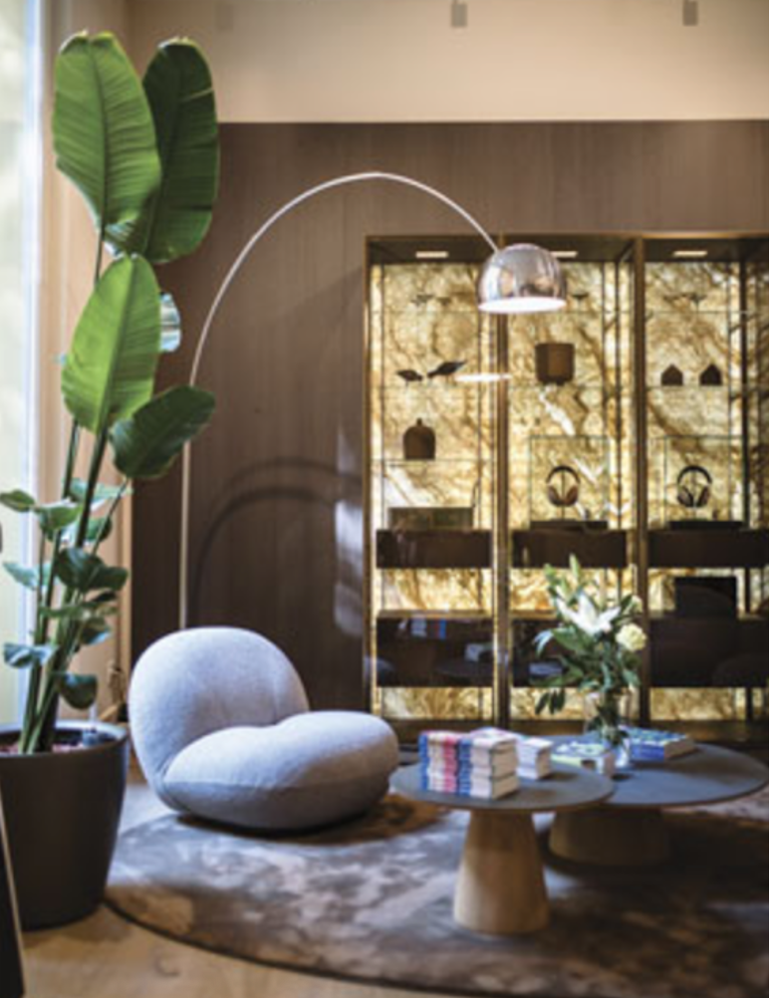
The SieMatic SLX Tall Display Cabinets turn storage into a showcase. Illuminated stone back panels provide a dramatic backdrop for glassware, art, and collected objects, while patterned glass introduces texture and visual depth. Rather than concealing what is stored within, the cabinets frame and illuminate those objects, making them an intentional part of the room’s composition.
SieMatic SE 3003 RFHM

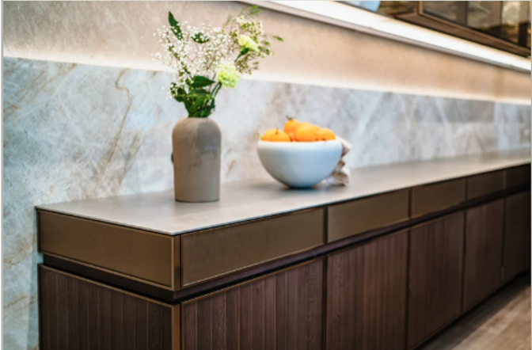
Bringing a new level of material expression to cabinetry, the SieMatic SE 3003 RFHM combines refined veneers with precisely integrated metal inlays. Inspired by techniques used in automotive interior manufacturing, the collection achieves an exceptional level of precision where the two materials meet. The result is a fine pinstripe effect reminiscent of a Maybach dashboard, where the interplay of wood, metal, and framing creates a distinctive design signature.

Freestanding Kitchen Buffet

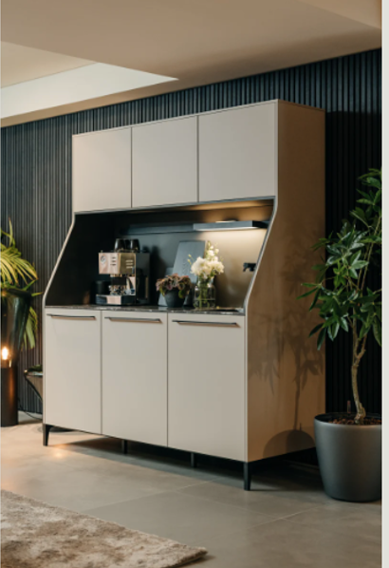

A signature piece of the SieMatic URBAN style, the SieMatic 29 freestanding kitchen buffet exemplifies the company’s furniture-inspired approach to cabinet design. Its refined proportions and distinctive design give it the character of furniture, allowing it to anchor the kitchen while also lending itself to use in other areas of the home, from dining and living spaces to wet bars and entryways. Available in all SieMatic materials and colors, including custom options, the piece can be tailored to complement a range of interiors.

Fluted Credenza

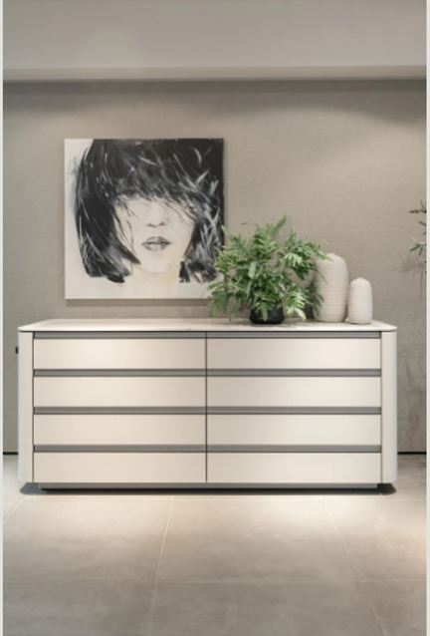

SieMatic’s SG6 brings a soft, furniture-inspired expression to the kitchen with its distinctive fluted fronts and gently rounded forms. The design moves beyond the look of traditional cabinetry, creating a piece that could just as naturally complement a dining or living space. Its refined detailing and handle-free design balance warmth and simplicity, reinforcing the SieMatic SG6 vision of the kitchen as an integrated part of the home.

Together, these elements reflect SieMatic’s evolving vision for the home—one in which the kitchen connects naturally with the spaces around it and design moves fluidly from one room to the next. By looking beyond the kitchen, SieMatic opens new possibilities for creating a more unified and personal home where the kitchen is a starting point—not a boundary.

About SieMatic
SieMatic is a premium kitchen brand with a long history and an international reputation for excellence in design, timeless elegance, and a high level of functionality. The company’s constantly evolving reinterpretation of the modern kitchen is exemplified by the design principle behind its four style collections: PURE, MONDIAL, URBAN, and CLASSIC. SieMatic products are manufactured in Germany under environmentally responsible standards with a commitment to providing distinctive kitchen solutions. They are available in over 60 countries throughout five continents. For more information about SieMatic and its products, call (215) 604-1350 or visit siematic.com.

###

